**Predictive Processing and temporal predictability in visual domain**.

Sanjeev Nara 1 Mikel Lizarazzu 1 Craig G Richter 1 Diana C Dima 4 Radoslaw M Cichy 3 Mathieu Bourguignon 1,2 Nicola Molinaro 1

1. Basque Center for Cognition, Brain and Language , San Sebastian, Spain
2. Laboratoire de Cartographie fonctionelle du Cerveau, UNI – ULB Neuroscience Institute, Université libre de Bruxelles (ULB), Brussels, Belgium
3. Department of Education and Psychology, Free University Berlin, Berlin, Germany
4. John Hopkins University, Baltimore , USA

**Introduction**

Predictive processing is a framework that explains how the brain interacts with the external environment through sensory modalities[1]. The core idea behind all the predictive processing theories is that the brain predicts the environment around it and develops a generative model [2]. The model is constantly updated through the comparison of predicted and actual inputs. This process follows a cortical hierarchy (processing hierarchy), during which the higher-order brain areas make a prediction (top-down descending activation) and the lower order brain areas (bottom-up ascending activations) gets the actual stimulus input. The difference between both the actual input and prediction is termed as prediction error and this error signals update the internal generative model of the environment around us [3].

This framework has also been termed by different names such as predictive coding and hierarchical predictive coding etc., but the key elements remain the same *“Prediction”* and *“Prediction errors”* [4], [5]. The predictive processing framework accounts for underlying cognitive processes in both humans as well as animals [6]. Particularly, predictive processing accounts for visual perception [7][8] and auditory perception [9], speech perception[10], language [11] and music [12]. The framework also explains the abnormal neural functioning disorders like autism [13], psychosis [14] and several others.

In this hierarchical framework, the input stimuli received by the lower order brain areas (i.e. primary sensory cortices) may have several features. A visual stimulus may have features like edges, orientations, color, shape and other properties, whereas the audio signal might have features like volume, amplitude, frequency, pitch etc. These features compose the basis of perception and are related to identifying the stimuli that often contain the *WHAT* information i.e the context. But in real life situations the timing of the input stimuli also matters a lot. You may see a car coming toward you on the road, even after having all the *WHAT* information features, the *WHEN* information is also important for avoiding a collision. The same principle holds valid in auditory domain, for instance, how fast or slow you listen to the input shapes your perception. This *WHEN* information has gained less interest than the *WHAT* information. The *WHEN* information about the stimuli might be either predictable or unpredictable (temporal predictability in general).

These *WHAT* and *WHEN* features interact with each other and shape the human perception, thus, understanding the interaction of *WHAT* and *WHEN* in human perception ignites a new path of understanding human cognition. Most of the experiments in predictive processing research have studied prediction effects with just two components (i.e a cue and a target). This has been reported as a match and mismatch prediction effects based on match/mismatch of cue and target. To investigate the effect of temporal predictability on prediction, there should be longer sequences of cues that lead to stronger predictions, which helps to understand how the temporable predictability affects the generation of predictions. Faidella et al [15] attempted to understand this interaction in the auditory domain, but the limitation of the electroencephalography (EEG) modality (restricted to source level inferences only) and the experimental design did not shed proper light on this interaction. Auksztulewicz et al [16] studied this interaction using ECOG data, but the small number of participants and exclusion attention modulations failed to properly investigate the interaction of *WHAT*and *WHEN*.

Both attention and prediction are top-down processes and both affect human perception. Theories of prediction relates to neural (mental) models infer about (present or future) sensory or action-related information, whereas theories of attention are about the control of information flow underlying perception and action. Both processes are related and not always clearly distinguishable [17] Whereas there has been a lot of evidence about the feature-specific attentional abilities that means the focussed and divided attention are dissociable [18][19][20]. This motivates us to investigate attention and prediction by designing an orthogonal task, where attention is diverted to one feature of the stimuli while prediction is related to the other feature. This design aims to investigate the prediction effects in less/diverted focus of attention.

In this experiment we focus on visual domain interaction of *WHAT* and *WHEN* information, and we aim to investigate the prediction effects in less focus of attention. We manipulated participants to attend to one feature of the stimuli, cycles per degree of a Gabor patch (CPD), and predict the other feature, the orientation of the Gabor patch, in a sequence of four Gabors. The feature being attended is present at the Target. We planned to measure the effect of temporal predictability on the four Gabor patches, which are in less focus of attention.

The presentation of Gabors may either enhance or suppress the neural response based on temporal predictability. This kind of suppression or enhancement has been studied through different experimental paradigms like neural adaptation, repetition suppression, repetition enhancement, mnemonic filtering, decremental response and neural priming [21]. On one hand, temporal predictability could possibly enhance the repetition suppression effect due to the two sources of information about the stimuli (i.e timing and orientation). On the other hand, it is possible that the neural responses are enhanced when the timing information is unpredictable as the system increases the reliance on the internal model to reduce the uncertainty of the external stimuli. We do so through a conventional evoked analysis approach and advanced analysis like source reconstruction.

Multivariate pattern analysis (MVPA) has gained a lot of interest in recent years due to higher computational power and machine learning literature. Studies report decoding of the orientation, position, identity, angle, seen and unseen information from EEG and MEG signals at every time instance or every sample [22][23], [24]. It will be interesting to decode the orientation of each presented Gabor during less focus of attention, representing the developing predictions.

**Methods**

**Participants**

Seventeen (xx Females, mean age xx +/- xx years old) took part in the present study. The ethical committee and scientific committee of Basque Center on Cognition, Brain and Language (BCBL) approved the experiment (following the principles of the Declaration of Helsinki) and each participant signed an informed consent form. Each participant was paid 10 € per hour for their valuable contribution. The participants were recruited from BCBL web participa and all the participants were free from any neurological and psychological disorders. All the participants had normal or corrected to normal vision.

**Experimental Design**

To address the experimental questions, we developed an experimental paradigm, in which simple visual stimuli (Gabor patches) were present with various numbers of dimensions like orientation and CPD. Four Gabor patches were presented for 200 milliseconds sequentially (with the inter-stimulus interval of 200 ms) and constitute the contextual information (entrainers). After 600 ms, a fifth Gabor patch (target) was presented. The entrainers had an intermediate number of CPD of visual angle. Participants were asked if the target had a higher or a lower CPD with respect to the entrainers. Prediction, however, was related to a different feature of the stimuli. The Gabor orientation always changed across the five visual stimuli (entrainers and target) but could either change randomly or scaled/systematically (clockwise or counterclockwise). In the latter case, the orientation of the target was predictable. This design drove the participants’ attention to the CPF feature, while manipulating the orientation for estimating the predictive processes that are supposed to be automatic. The design includes a temporal prediction dimension as well: the time gap (inter-stimulus interval) before the target Gabor could be predictable (fixed time gap, i.e 200 ms) or could be unpredictable (random time gap between 70 - 330 ms). This dimension made predictable and unpredictable dissociable in the two dimensions (predicting what and predicting when), and they are summarized in Table 1 and Figure 1

|  |  |  |
| --- | --- | --- |
|  | Predictable gabor orientation | Unpredictable gabor orientation |
| Predictable time gap (Inter stimulus interval ISI) | Predictable Orientation, Predictable Timing  (WHAT + WHEN) | Unpredictable Orientation, Predictable Timing  (WHEN Only ) |
| Unpredictable time gap  (Inter stimulus interval ISI) | Predictable Orientation, unpredictable Timing  (WHAT Only) | Unpredictable Orientation, Unpredictable Timing  (Random / None ) |

Table 1: Experimental design

**Table 1.** A total of 160 trials was acquired for each condition (80 horizontal targets and 80 vertical targets) leading to a total of 640 trials per participant. 40 trials of Functional localizers of both horizontal and vertical targets were also acquired during the experiment.

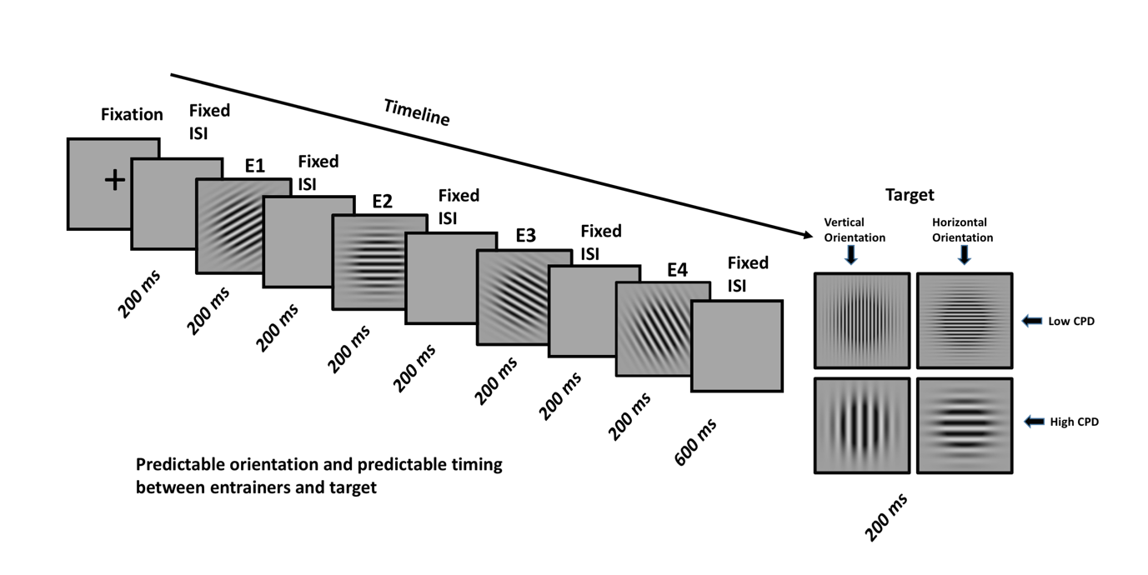

Figure 1a: Predictable orientation and predictable timing (What + When information)

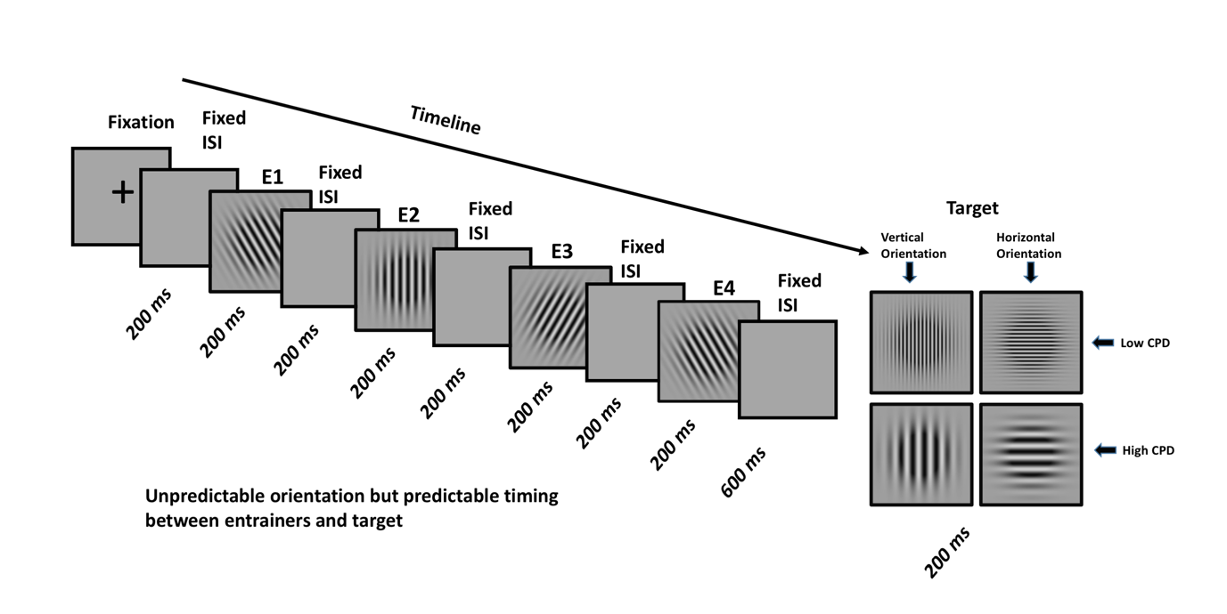

Figure 1b: Unpredictable orientation but predictable timing (When Only information)

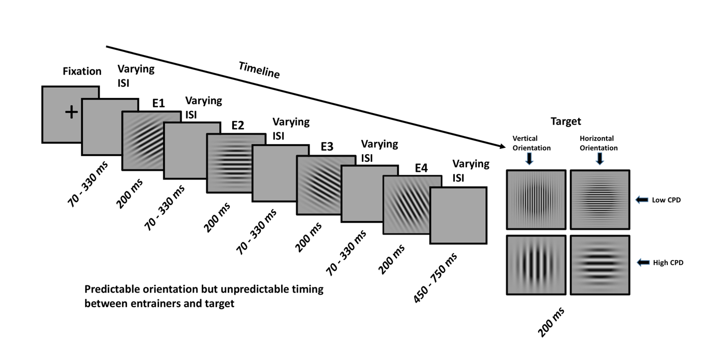

Figure 1c: Predictable orientation but unpredictable timing (What Only information)

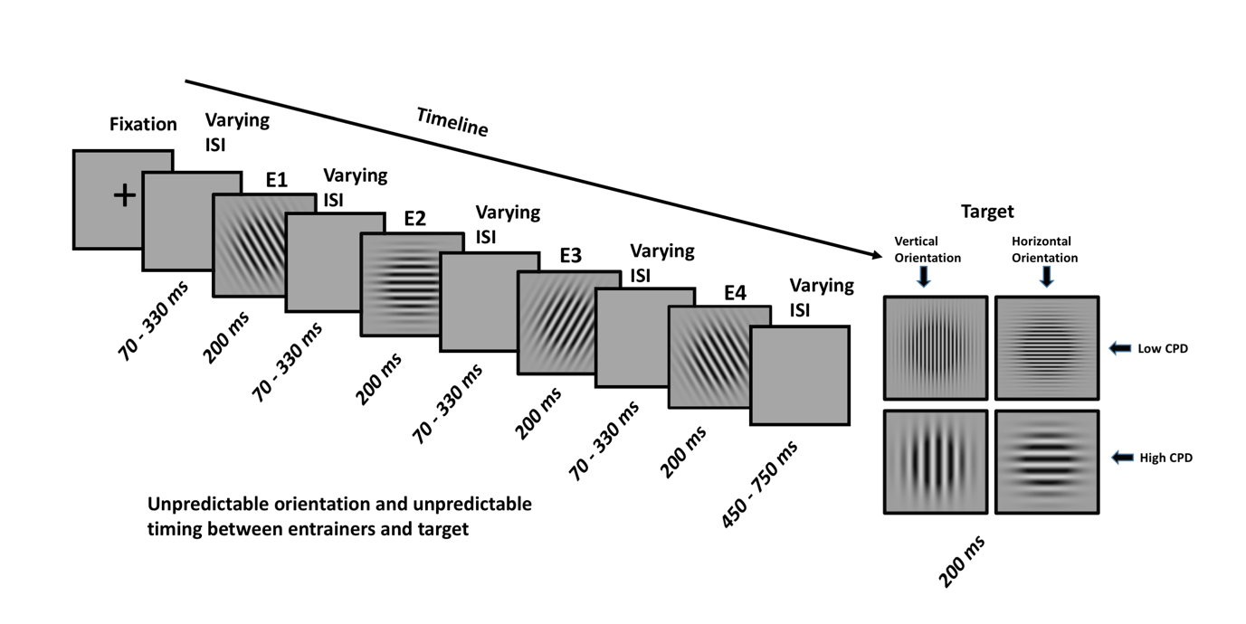

Figure 1d: Unpredictable orientation and unpredictable timing (Random/None information)

**Data Acquisition**

MEG data were acquired using MEG facility available at Basque Centre on Cognition, Brain and Language (BCBL, San Sebastian, Spain) in a magnetically shielded room using the whole-scalp MEG system(Elekta NeuromagR©, Helsinki, Finland). The MEG system is equipped with 306 sensors distributed around the participant’s head. The sensors are arranged in triplet configuration of one magnetometer and two orthogonal planar gradiometers. To keep a track of head movement five (05) magnetic head position indicator (HPI) coils were also placed around the head. The initial location of the hpi coils and the three reference points i.e nasion, right auricular point and left auricular point was obtained by a 3D digitizer (Polhemus Fastrak, Colchester, VA, USA). This initial and reference point information is crucial in head motion correction during max filtering. Three hundred ( 300) additional points of the scalp of participant’s head were also obtained which helps in better co-registration of the MRI T1 images of each participant acquired at the MRI facility available at BCBL. The MRI data were acquired using a three tesla (3T) MRI machine (3T MAGNETOM PRISMAfit MR, Siemens Medical System, Erlangen, Germany) with MP2RAGE mri sequence. The MEG data was acquired at 1kz sampling rate with bandpass filter in range 0.1 to 330 Hz. Cardiac artifacts (ECG) and ocular artifacts (EOG, both blinks and saccades) were also recorded during the acquisition.

**Data preprocessing**

The initial preprocessing was performed using maxfilter software (Maxfilter 2.2). Spatiotemporal signal space separation (tsss) [25] along with movement correction was applied to the data. The bad channels were interpolated from neighbouring sensors with algorithms implemented in maxfilter software. The data were then corrected for jump artifacts and muscle artifacts. The ocular and cardiac artifacts were automatically removed using ICA (runica) and coherence based method available on fieldtrip website [fieldtrip reference] using Matlab [matlab reference].

**Evoked Analysis**

The raw data was bandpassed between 0.5 and 45 Hz for the evoked response analysis. The planar gradiometers were combined resulting 102 channels that were used for subsequent analysis. The data was segmented from the onset to the end of the presentation for each entrainer. Segmented data were averaged for each participant for different conditions. Baseline correction was also applied to the evoked data considering 400 milliseconds data prior to the cross fixation presented at the beginning of each trial. Statistical differences were estimated using a nonparametric permutation test and corrected for multiple comparisons using cluster-based technique [27].

Source Reconstruction

Source reconstruction was performed on averaged segmented data (evoked data) to find out the brain areas generating the differential effect on sensor space. The source reconstruction pipeline used here has also been reported in previous work[28]. Linearly constrained minimum variance beamformer (LCMVB)[29] approach was used for creating a spatial filter. T1 weighted high resolution images from 14 participants ( three participants did not perform the MRI session) were parcellated using freesurfer software[30][31]. The MEG and MRI coordinates were co-registered based on three fiducial points and marker points on brain scalp acquired during the head digitization. One shell realistic head model was created from the parcellated MRI data. The forward model was computed for three orthogonal source orientations, placed on a 5 mm grid covering the whole brain using MNE suite [32] (Martinos Centre for Biomedical Imaging). Each source was then reduced to its two principal components of highest singular value, which closely correspond to sources tangential to the skull. Both planar gradiometers and magnetometers were used for inverse modelling after dividing each sensor signal (and the corresponding forward-model coefficients) by its noise standard deviation. The noise variance was estimated from the 400 ms baseline prior to the cross fixation in every trial.

A priori time windows based on sensor space data was selected for each entrainer (85 – 125 msec post presentation of the Gabor ). LCMV inverse solution was used to project the ERF data into source space, using a noise covariance matrix estimated from a 400 ms before the cross fixation. Source power in the selected time window was averaged and normalized by the power in the baseline. For computing the group level analysis, the individual MRIs were mapped to the standard Montreal Neurological Institute (MNI) brain through a non-linear transformation using the spatial-normalization algorithm implemented in Statistical Parametric Mapping (SPM8) [33], and the ensuing spatial transformations were applied to individual maps. We identified the coordinates of local maxima (sets of contiguous voxels displaying higher power than all other neighboring voxels). The SPM coordinates were then transformed into freesurfer coordinates and the source activity was plotted using TKsurfer tool available in freesurfer software .

Statistical inferences were computed using nonparametric tests and finding out the local maxima in the group maps.

MVPA

To decode the feature specificity (i.e orientation of Gabor), the data was segmented at every entrainer from 100 msec prior to the onset of the entrainer till 350 ms post presentation of entrainer 1, 2 and 3. Since the time gap between target and Entrainer was more compared to earlier entrainers, the data was segmented from -100 msec to 600 msec post presentation of the Gabor patch. The data were classified using a linear support vector machine (SVM) classifier with L2 regularization and a box constraint of c=1. The classifier was implemented in Matlab using LibLinear [34] and the Statistics and Machine Learning Toolbox (Mathworks, Inc.). We performed a binary classification on the orientation of Gabor relative to the target. The classes (i.e., horizontal or vertical) were derived from the target orientation: if the target orientation was horizontal all the preceding orientation in the corresponding conditions were labeled as horizontal and vice versa.

The data was down-sampled to 200 Hz prior to the classification. Pseudo trials were generated to improve the SNR by averaging the trials in a set of 5 for each class [35]. This pseudo trial generation was repeated 100 times to generate the trials with a higher signal to noise ratio. The data was then randomly partitioned using 5-fold cross-validation . The classifier was trained on 4 folds and tested on 1 fold and this process was repeated until each fold is left out once. To improve data quality, we performed multivariate noise normalization[36]. The time-resolved error covariance between sensors was calculated based on the covariance matrix (Σ) of the training set (X) and used to normalize both the training and test sets in order to down weight MEG channels with higher noise levels.

Results

To address the experimental question, “how the temporal predictability affects the development of predictions”, cluster-based permutation test was applied to evoked data corresponding to every entrainer (E1, E2, E3, and E4). The common baseline was selected for all the conditions and entrainers i.e 400 hundred milliseconds before the fixation in the data. The alpha threshold was considered as 0.01 and the time window for cluster-based permutation test was selected from 0 – 270 msec with 1000 random permutations. To access the strong and localised clusters during correction, the cluster alpha parameter was also set to 0.01 (Table 2.).

|  |  |  |  |  |
| --- | --- | --- | --- | --- |
|  | Entrainer 1 | Entrainer 2 | Entrainer 3 | Entrainer 4 |
| What + When  Vs  When Only | No Significant Differences | 95 – 105 msec (p< 0.01) | 96 – 110 msec  (p< 0.001) | 97 – 121 msec  (p<0.001) |
| When Only  Vs  None/Random | No Significant Differences | 95 – 109 msec (p< 0.001) | 94 – 113 msec  (p< 0.001) | 96 – 129 msec  (p<0.001) |

**Table 2.** some description

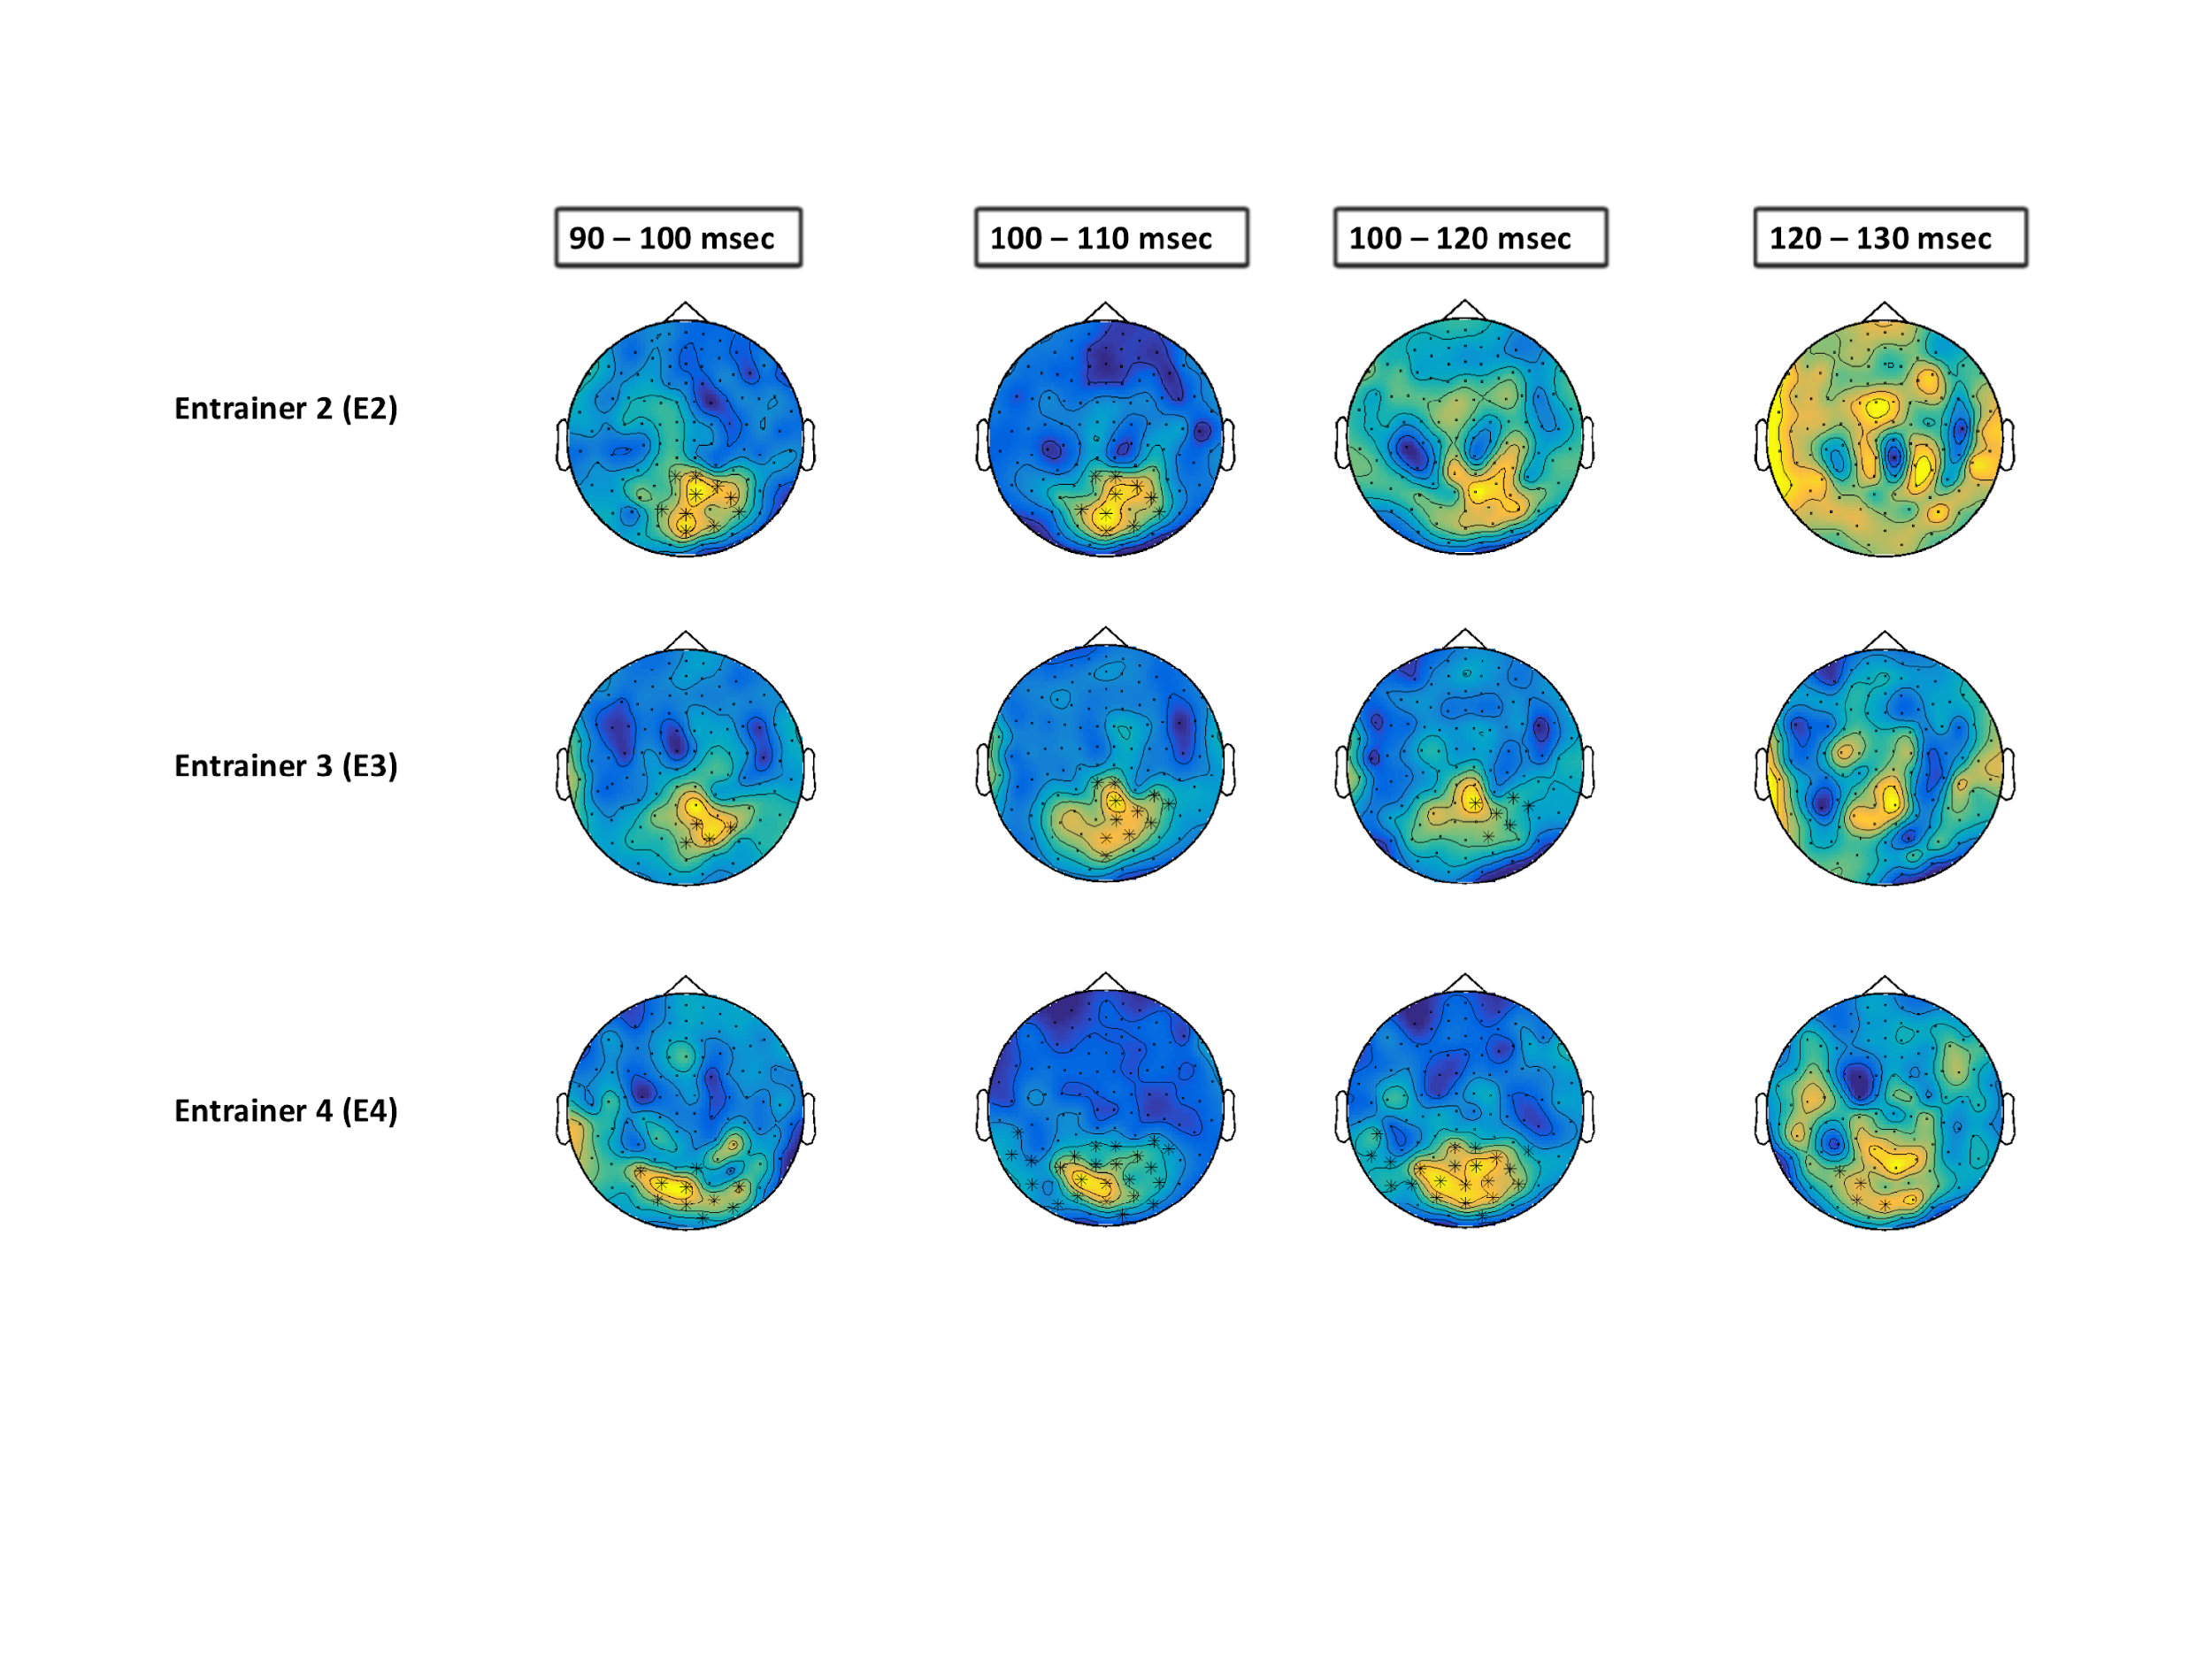

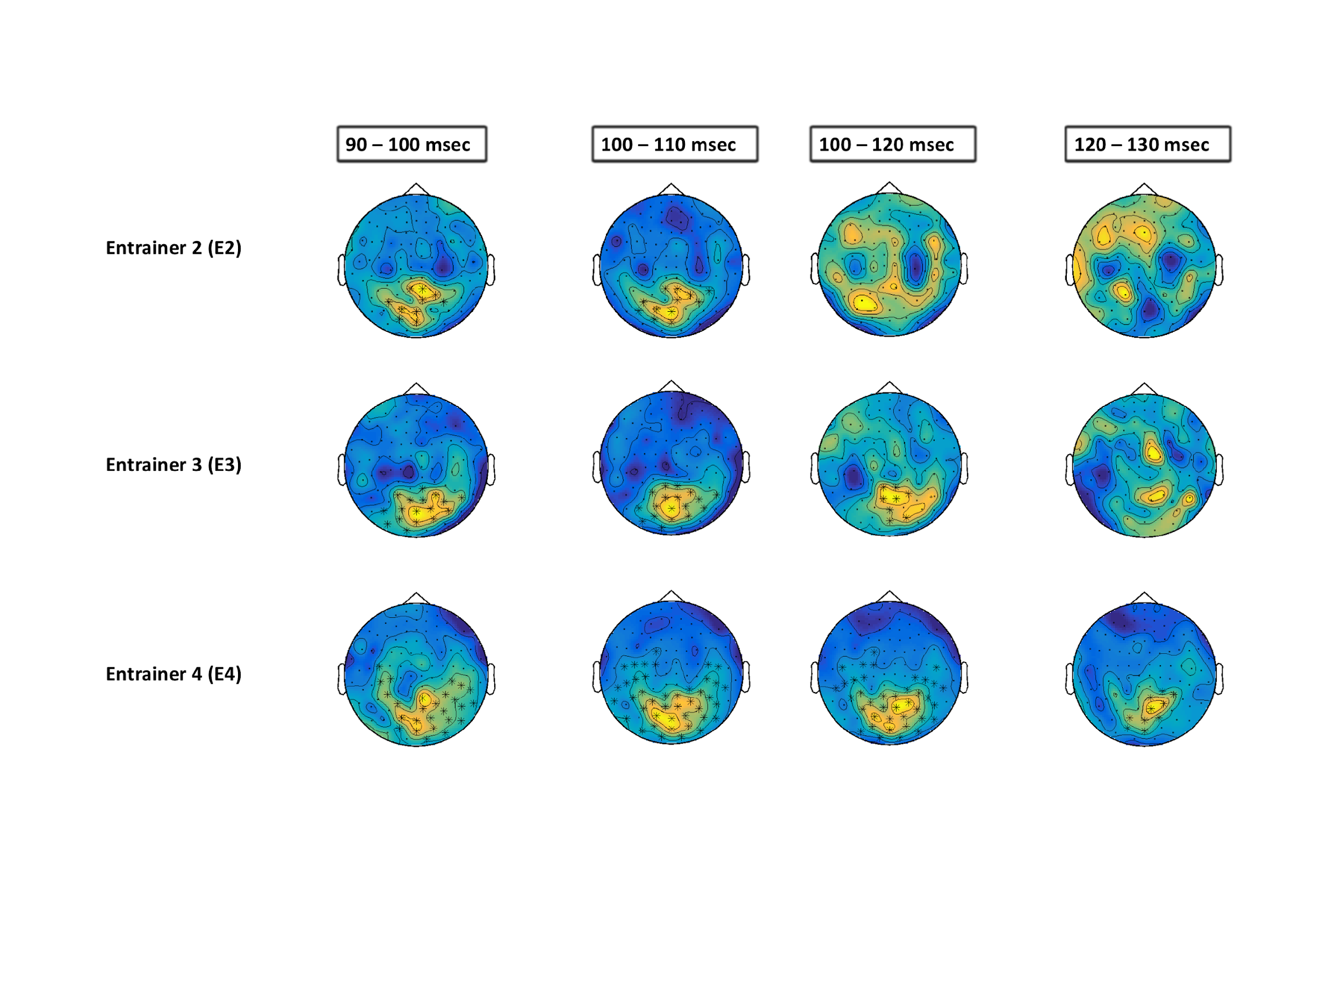

**Figure 2.** The topographic information of differences along with the highlighted channels below the threshold,

**Source Reconstruction**

The evoked analysis shows that there are significant differences between conditions that start from entrainer 2 and the effect goes stronger as we move ahead in time. The number of channels involved in the difference is also increasing which refers to the higher differences across conditions. The local maxima were computed within every condition. Table 2 shows the significant local maxima obtained in every group map at every entrainer.

|  |  |  |  |  |
| --- | --- | --- | --- | --- |
|  | E 1 | E2 | E3 | E4 |
| What + When | -1 -92 -12 | -1 -89 -15  19 -95 12 | 1 -90 -14  22 -95 12 | 0 -91 -12 |
| When Only | -1 -93  -9 | -1 -90 -14  20 -95 13 | 0 -91 -13  22 -95 14 | 0 -91 -13  22 -95 -13 |
| What only | -2 -93 -9 | -2 -89 -16  22 -95 12 | 0 -90 -14  22 -95 11 | -1 -92 -10 |
| None / Random | -2 -93 -9 | 0 -91 -13  18 -94 14 | 1 -91 -13  21 -95 12 | 0 -92 -11  21 -95 13 |

**Table 3.** some description

The first MNI coordinate [-1 -91 -12] was considered for further analysis, considering the spatial resolution of MEG and the spectral leakage limitation in the inverse operation methods, all the local maxima within a few mm of the first maxima are supposed to have same neural source. Taking the MNI coordinate [-1 -92 -12] as center a sphere having 5mm diameter was drawn in the MNI space. The maximum source activity within this sphere was calculated for every participant. To find out if the means of groups come from the same or different distribution, one sample dependent t-test was applied to the power ratio values across conditions. Figure 3 shows the t-values compared between conditions having temporable predictability (i.e *What + When vs When Only* ) and without temporable predictability (i.e *What only vs None*).

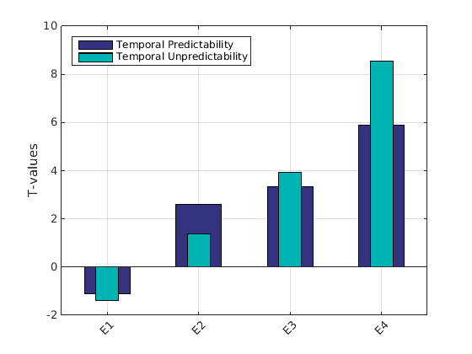

**Figure 3.** some description

It is evident from the t value differences that conditions having temporable predictability are processed faster in time (i.e the differences start at E2) whereas the conditions lacking temporable predictability are processed later but then the differences become stronger compared to conditions having temporable predictability.

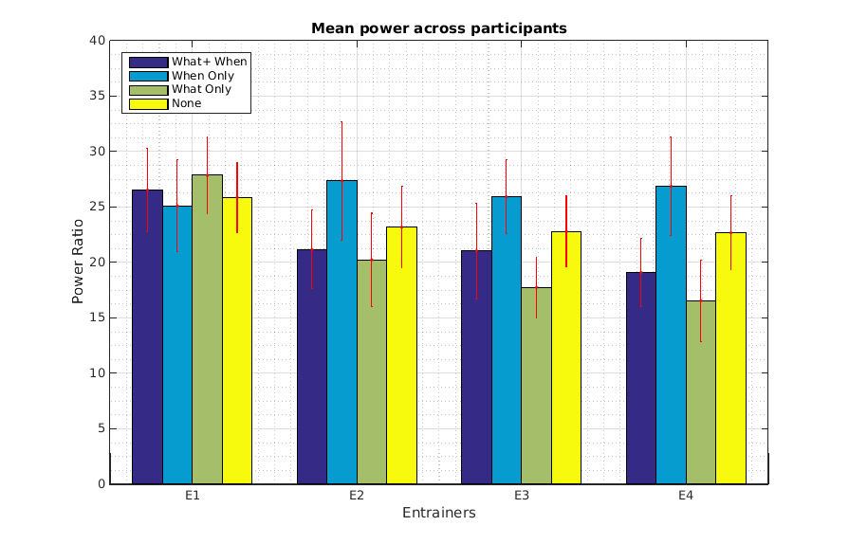

**Figure 4.** The mean of power ratios at every condition across entrainers.

The conditions having predictable orientation (i.e *What + When and When Only)* reduces the neural activity as participants moved across the entrainers, whereas the conditions without the orientation predictability did not show such reduction.

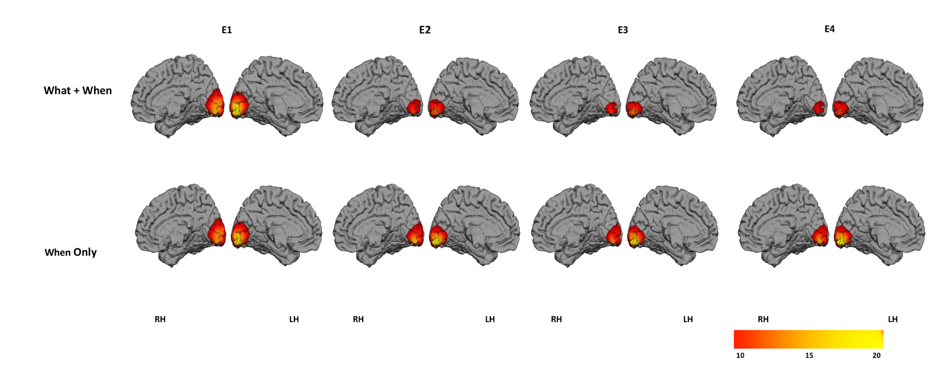

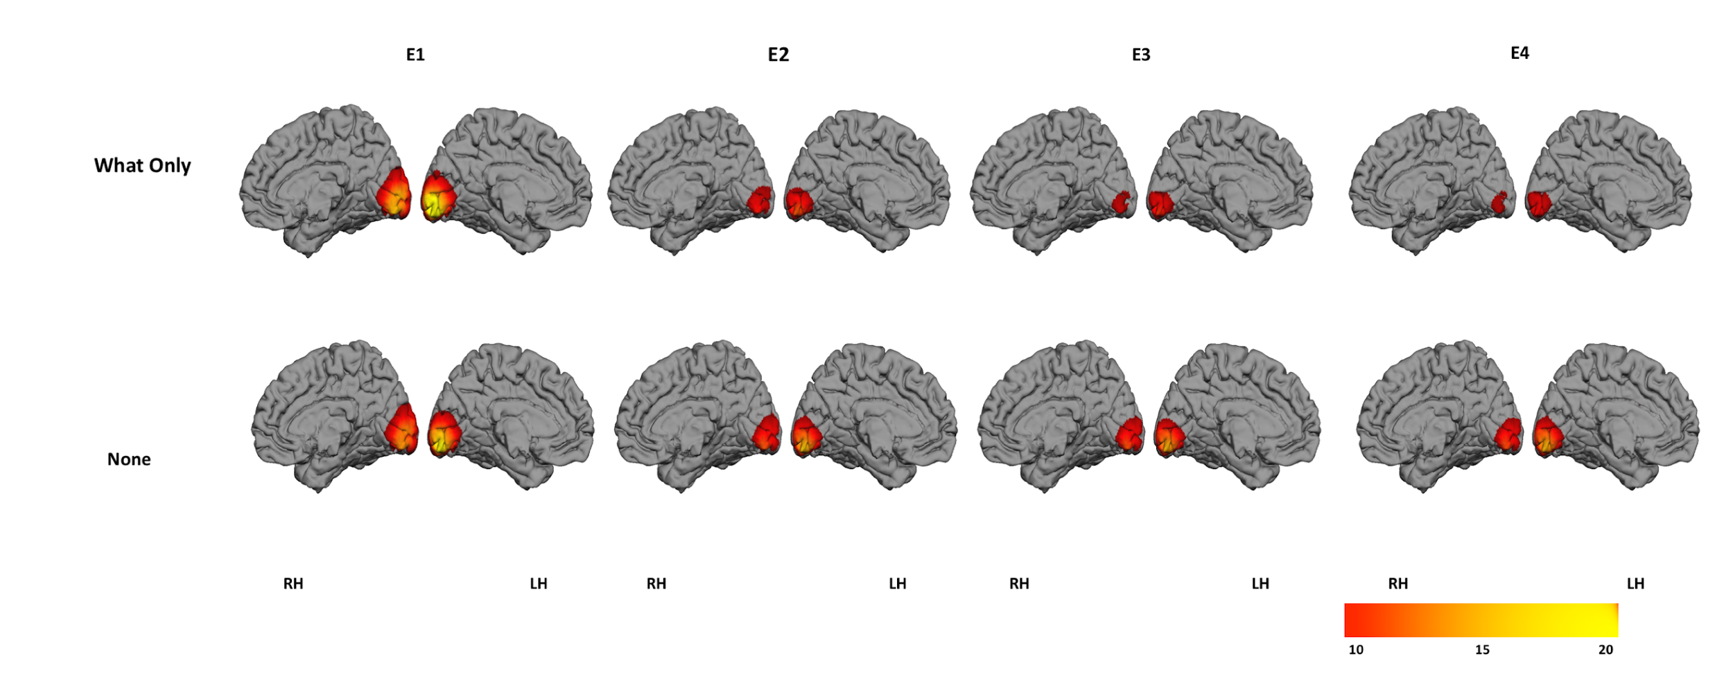

**Figure 5.** The group activity of the conditions with and without temporal predictability.

**MVPA results**

The data was time-locked to each entrainer in a time range of -100 msec to 350 msec (will change it ) post presentation of the Gabor for entrainer 1 to entrainer 3. Since the entrainer 4 has a longer time gap between the entrainer and target so data was selected from -100 to 600 msec post presentation of Gabor. Each trial was labeled as horizontal or vertical relative to the target. For example, a trial was labeled Horizontal if the target i.e fifth gabor patch has a horizontal orientation angle of the Gabor patch. Figure 6 shows the decoding of horizontal versus vertical targets at every entrainer.

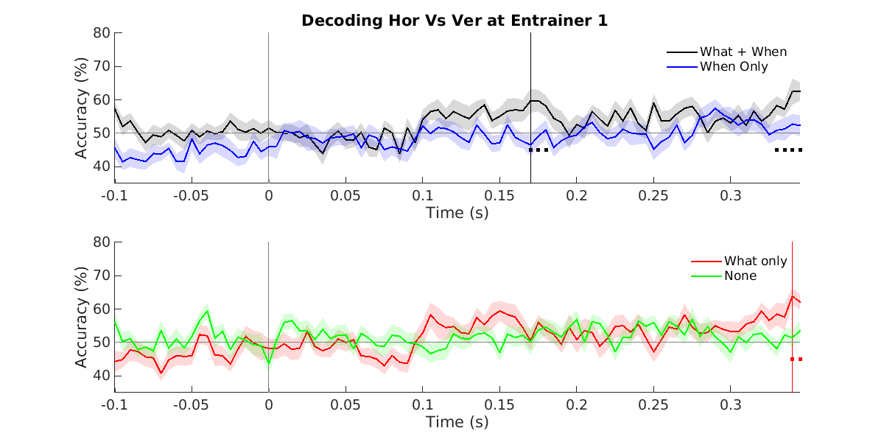

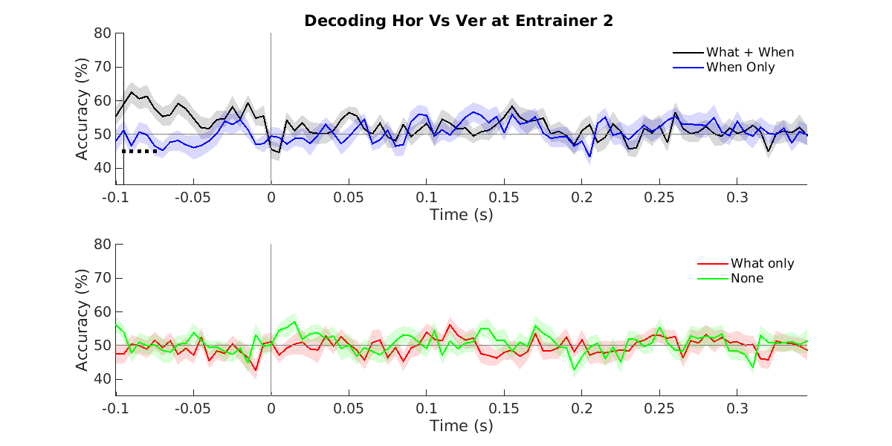

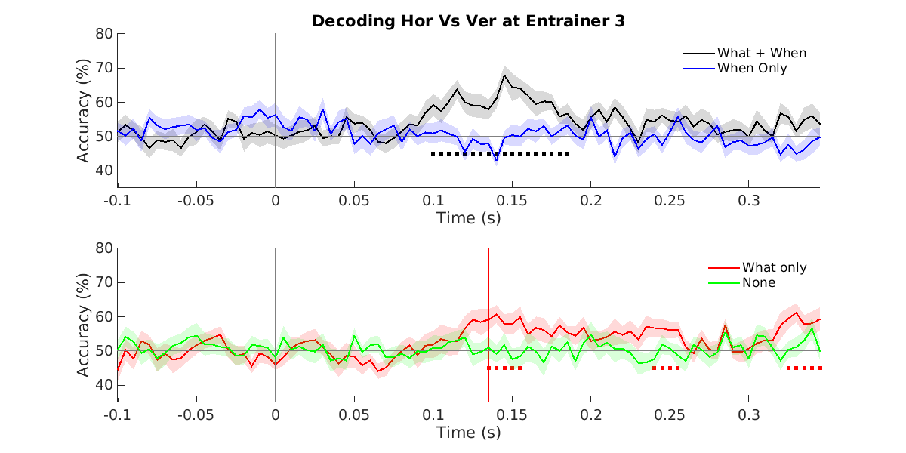

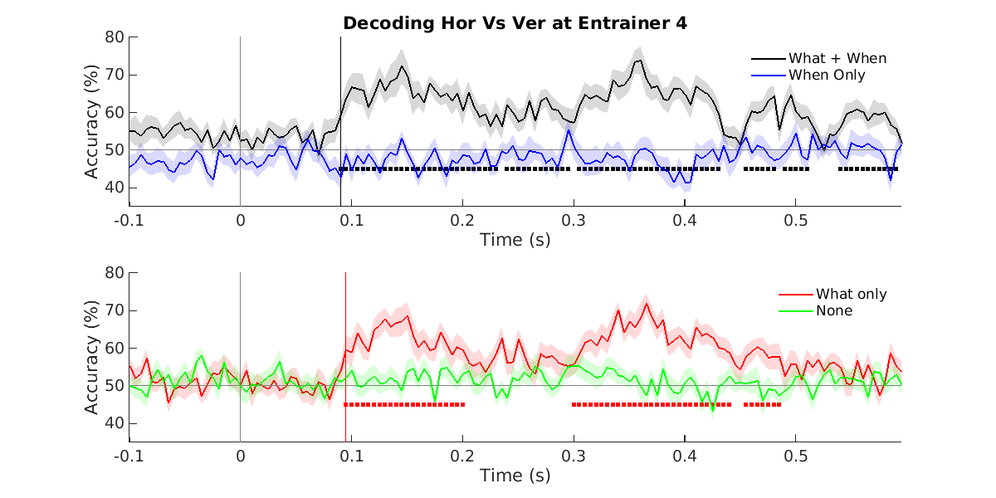

**Figure N.** some description

It can be inferred from figure 5 that decoding of the orientation is not decodable at entrainer 1 (E1) in all the four conditions. The same holds true for entrainer 2. As time progresses to entrainer 3, the conditions having the information about the orientation (i.e *What + When and What only*) shows above chance and statistically significant decoding accuracy. At entrainer 3, the significant decoding starts around ~ 90 milliseconds in condition having temporable predictability, whereas the condition lacking temporable predictability starts around ~ 135 milliseconds. The decoding is also consistent in condition having temporable predictability whereas the condition lacking temporable predictability is recurrent in nature. At Entrainer 4, the difference between the first decoding point is almost similar whereas the decoding of orientation is constant for a longer time in condition having temporal predictability (i.e *What + When* ) compared to the condition lacking temporable predictability (i.e *What Only* ). It is also worth noticing the conditions which don’t have the information about the orientation of the Gabor patch (i.e *When only and None* ) , the decoding accuracy is always around chance which reflects the effectiveness of the classifier used.

**Discussion**

In the present study we have focussed on investigating how the temporable predictability of input stimuli affects predictions in less focus of attention. We observed significant differences in evoked data arising from occipital brain areas. The source reconstruction of these differences shows the differences arising from Left visual association areas ( Broadman area 17 ) present in the V2 layer of the visual cortex. This brain area is responsible for extracting the complex features from input stimuli.

In our future study we aim to investigate the frequencies which undergo neural adaptation. We will do a source reconstruction of individual frequencies mainly beta and gamma to find frequency-specific adaptation. We also aim to use connectivity measures on brain sources between lower and higher-order brain areas.

**Acknowledgement** : This research is supported by the Basque Government through the BERC 2018-2021 program and by the Spanish State Research Agency through BCBL Severo Ochoa excellence accreditation SEV-2015-0490 and through project BES-2016-077560 funded by the Spanish Ministry of Economy and Competitiveness (MINECO). The authors do acknowledge Asier Zarraza, Ning Mei, Dr David Soto and Dr Lucia Amoruso for their comments on initial draft of this publication.

Declaration : The **author**(s) **declare**(s) that there is **no conflict of interest** regarding the publication of this article.

**References :**

[1] A. Clark, “Whatever next? Predictive brains, situated agents, and the future of cognitive science,” *Behav. Brain Sci.*, vol. 36, no. 3, pp. 181–204, 2013.

[2] M. W. Spratling, “A review of predictive coding algorithms,” *Brain Cogn.*, vol. 112, pp. 92–97, 2017.

[3] G. B. Keller and T. D. Mrsic-Flogel, “Predictive Processing: A Canonical Cortical Computation,” *Neuron*, vol. 100, no. 2, pp. 424–435, 2018.

[4] K. Friston, “A theory of cortical responses,” *Philos. Trans. R. Soc. B Biol. Sci.*, vol. 360, no. 1456, pp. 815–836, 2005.

[5] R. P. N. Rao and D. H. Ballard, “Predictive coding in the visual cortex: A functional interpretation of some extra-classical receptive-field effects,” *Nat. Neurosci.*, vol. 2, no. 1, pp. 79–87, 1999.

[6] C. G. Richter, W. H. Thompson, C. A. Bosman, and P. Fries, “Top-down beta enhances bottom-up gamma,” *J. Neurosci.*, vol. 37, no. 28, pp. 6698–6711, 2017.

[7] G. Stefanics, G. Stefanics, J. Kremláček, and I. Czigler, “Visual mismatch negativity: A predictive coding view,” *Front. Hum. Neurosci.*, vol. 8, no. September, pp. 1–19, 2014.

[8] L. H. Arnal and A. L. Giraud, “Cortical oscillations and sensory predictions,” *Trends Cogn. Sci.*, vol. 16, no. 7, pp. 390–398, 2012.

[9] M. Heilbron and M. Chait, “Great Expectations: Is there Evidence for Predictive Coding in Auditory Cortex?,” *Neuroscience*, vol. 389, pp. 54–73, 2018.

[10] M. Hakonen, P. J. C. May, I. P. Jääskeläinen, E. Jokinen, M. Sams, and H. Tiitinen, “Predictive processing increases intelligibility of acoustically distorted speech: Behavioral and neural correlates,” *Brain Behav.*, vol. 7, no. 9, pp. 1–15, 2017.

[11] Gina R. Kuperberg and T. F. Jaeger, “What do we mean by prediction in language comprehension?,” *Physiol. Behav.*, vol. 176, no. 3, pp. 139–148, 2017.

[12] S. Koelsch, P. Vuust, and K. Friston, “Predictive Processes and the Peculiar Case of Music,” *Trends Cogn. Sci.*, vol. 23, no. 1, pp. 63–77, 2019.

[13] P. Sinha *et al.*, “Autism as a disorder of prediction,” *Proc. Natl. Acad. Sci. U. S. A.*, vol. 111, no. 42, pp. 15220–15225, 2014.

[14] P. Sterzer *et al.*, “The Predictive Coding Account of Psychosis,” *Biol. Psychiatry*, vol. 84, no. 9, pp. 634–643, 2018.

[15] J. Costa-Faidella, T. Baldeweg, S. Grimm, and C. Escera, “Interactions between ‘what’ and ‘when’ in the auditory system: Temporal predictability enhances repetition suppression,” *J. Neurosci.*, vol. 31, no. 50, pp. 18590–18597, 2011.

[16] R. Auksztulewicz *et al.*, “Not all predictions are equal: ‘what’ and ‘when’ predictions modulate activity in auditory cortex through different mechanisms,” *J. Neurosci.*, vol. 38, no. 40, pp. 8680–8693, 2018.

[17] E. B. V All and W. James, “Bridging prediction and attention in current research on perception and action,” vol. 1626, pp. 1–13, 2015.

[18] X. V. Wyart, N. E. Myers, and C. Summerfield, “Neural Mechanisms of Human Perceptual Choice Under Focused and Divided Attention,” vol. 35, no. 8, pp. 3485–3498, 2015.

[19] C. Summerfield and J. A. Mangels, “Dissociable Neural Mechanisms for Encoding Predictable and Unpredictable Events,” pp. 1120–1132, 2006.

[20] J. Jiang, C. Summerfield, and T. Egner, “Attention Sharpens the Distinction between Expected and Unexpected Percepts in the Visual Brain,” vol. 33, no. 47, pp. 18438–18447, 2013.

[21] K. Grill-Spector, R. Henson, and A. Martin, “Repetition and the brain: Neural models of stimulus-specific effects,” *Trends Cogn. Sci.*, vol. 10, no. 1, pp. 14–23, 2006.

[22] J. R. King, N. Pescetelli, and S. Dehaene, “Brain Mechanisms Underlying the Brief Maintenance of Seen and Unseen Sensory Information,” *Neuron*, vol. 92, no. 5, pp. 1122–1134, 2016.

[23] D. Pantazis, M. Fang, S. Qin, Y. Mohsenzadeh, Q. Li, and R. M. Cichy, “Decoding the orientation of contrast edges from MEG evoked and induced responses,” *Neuroimage*, vol. 180, no. July, pp. 267–279, 2018.

[24] R. M. Cichy, D. Pantazis, and A. Oliva, “Resolving human object recognition in space and time,” *Nat. Neurosci.*, vol. 17, no. 3, pp. 455–462, 2014.

[25] S. Taulu and J. Simola, “Spatiotemporal signal space separation method for rejecting nearby interference in MEG measurements,” *Phys. Med. Biol.*, vol. 51, no. 7, pp. 1759–1768, 2006.

[26] R. Oostenveld, P. Fries, E. Maris, and J. M. Schoffelen, “FieldTrip: Open source software for advanced analysis of MEG, EEG, and invasive electrophysiological data,” *Comput. Intell. Neurosci.*, vol. 2011, 2011.

[27] E. Maris and R. Oostenveld, “Nonparametric statistical testing of EEG- and MEG-data,” *J. Neurosci. Methods*, vol. 164, no. 1, pp. 177–190, 2007.

[28] I. F. Monsalve, M. Bourguignon, and N. Molinaro, “Theta oscillations mediate pre-activation of highly expected word initial phonemes,” *Sci. Rep.*, vol. 8, no. 1, pp. 1–14, 2018.

[29] B. D. Van Veen, W. Van Drongelen, M. Yuchtman, and A. Suzuki, “Localization of brain electrical activity via linearly constrained minimum variance spatial filtering. IEEE Transactions on,” *Biomed. Eng. (NY).*, vol. 44, no. 9, pp. 867–880, 1997.

[30] A. M. Dale, B. Fischl, and M. I. Sereno, “Cortical Surface-Based Analysis,” *Neuroimage*, vol. 9, no. 2, pp. 179–194, 1999.

[31] A. Dale and M. Sereno, “Improved localization of cortical surface reconstruciton: A linear approach.,” *J. Cogn. Neurosci.*, vol. 5, pp. 162–176, 1993.

[32] A. Gramfort *et al.*, “MNE software for processing MEG and EEG data,” *Neuroimage*, vol. 86, pp. 446–460, 2014.

[33] K. J. Friston, A. P. Holmes, K. J. Worsley, J. ‐P Poline, C. D. Frith, and R. S. J. Frackowiak, “Statistical parametric maps in functional imaging: A general linear approach,” *Hum. Brain Mapp.*, vol. 2, no. 4, pp. 189–210, 1994.

[34] R. E. Fan, K. W. Chang, C. J. Hsieh, X. R. Wang, and C. J. Lin, “LIBLINEAR: A library for large linear classification,” *J. Mach. Learn. Res.*, vol. 9, no. 2008, pp. 1871–1874, 2008.

[35] D. C. Dima and K. D. Singh, “Dynamic representations of faces in the human ventral visual stream link visual features to behaviour,” 2018.

[36] M. Guggenmos, P. Sterzer, and R. M. Cichy, “Multivariate pattern analysis for MEG: A comparison of dissimilarity measures,” *Neuroimage*, vol. 173, no. February, pp. 434–447, 2018.

**Supplementary Data :**

|  |  |  |  |  |
| --- | --- | --- | --- | --- |
|  | E1 | E2 | E3 | E4 |
| Cond_2 vs Cond_1 | -1.118 | 2.6157 | 3.335 | 5.8860 |
| Cond_4 vs  Cond_3 | -1.387 | 1.3875 | 3.9145 | 8.5556 |